VIDEO POWER CABLE

- PARTS:

QUANTITY: PART #: NOMENCLATURE: LENGTH:

1 PER MACHINE 17661- CONNECTOR, 12-PIN, N/A

1 PER MACHINE 19104- WIRE, YELLOW, 22 AWG 12 INCHES

1 PER MACHINE 19105- WIRE, BLUE, 22 AWG 12 INCHES

1 PER MACHINE 46776- SLEEVE, ¼” BLACK 10 INCHES

1 PER MACHINE 17585-1 HOUSING, 2-PIN, MOLEX N/A

2 PER MACHINE 18729- TERMINAL, CRIMP, GOLDPLATE N/A

- 12 – PIN CONNECTOR ASSEMBLY:

- SOLDER THE 22 AWG BLUE WIRE TO PIN #1 ON THE CONNECTOR IN ACCORDANCE WITH DIAGRAM #1.

- SOLDER THE 22 AWG YELLOW WIRE TO PIN #2 ON THE CONNECTOR IN ACCORDANCE WITH DIAGRAM #1.

- BURN THE ENDS OF THE SLEEVING.

- INSERT THE WIRES INTO THE SLEEVING AND ASSEMBLE THE CONNECTOR.

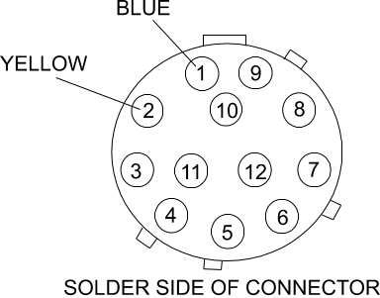
DIAGRAM #1

- OPPOSITE WIRE TERMINATIONS:

- STRIP 1/8 INCH OF INSULATION FROM THE OPPOSITE ENDS OF THE BLUE AND YELLOW WIRES.

- CRIMP A TERMINAL TO EACH WIRE, ACCORDING TO DIAGRAM 2.

- INSERT THE CRIMPED WIRES INTO THE HOUSING, ACCORDING TO DIAGRAM 3.



DIAGRAM 2



DIAGRAM 3

